# Backing up your Azure Database

I would suggest that you get into the habit of creating a local copy of your Azure database as a safeguard to any connection problems.

If you have already created several tables, it will take a little while the first time but if you get into the habit of creating a backup as you go it shouldn’t be too difficult to do.

There are three items you need to back up, the schema for each table, the data for the table and the definition for any stored procedures you have created.

## Backing up your Table Schemas

In Visual Studio open the database structure in SL Server Object Explorer like so…

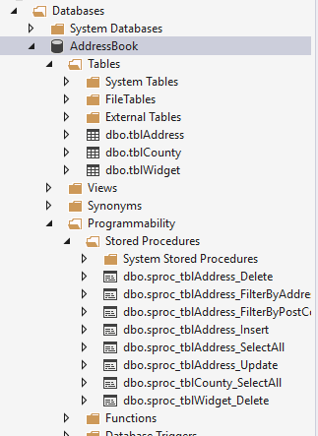

Start with the first table (in my case tblAddress) and right click on it selecting view designer…

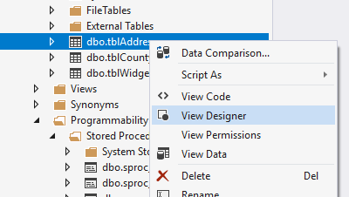

This will display the schema for the table…

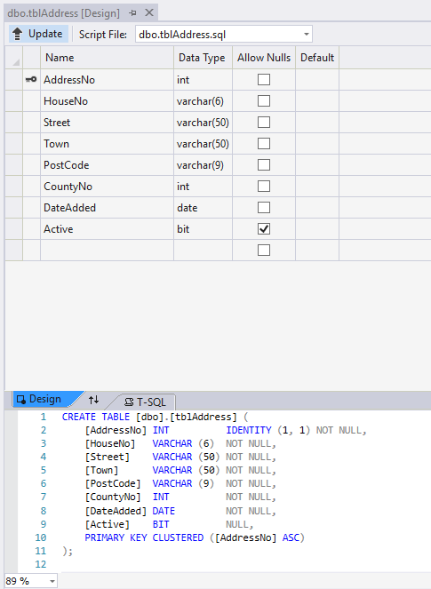

From the main menu select the following…

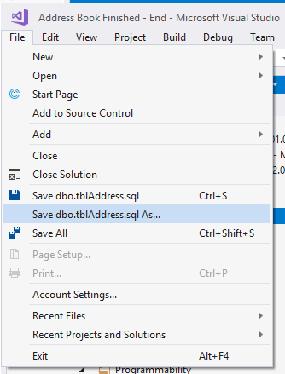

And save the definition into a local folder. It may be a good idea to place this in a OneDrive shared folder such that other team members have access too.

## Backing up your Stored Procedures

Backing up your stored procedures is like the above.

Right click on a stored procedure and select view code…

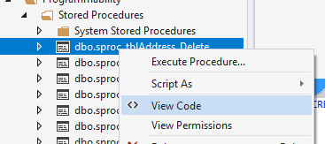

Again, from the main menu select the following…

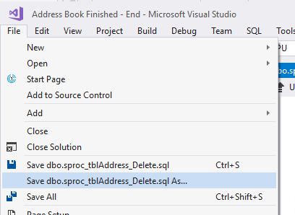

## Backing up your Table Data

Given that much of the data is temporary for this work it may not be as important to back it up. If you have some records that you feel are worth keeping do the following.

Pick a table to back up and right click on it like so…

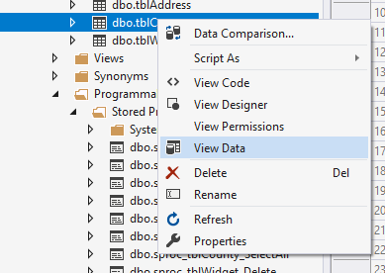

Select view data.

This will display the data in the table.

Click on the square at the top left of the columns…

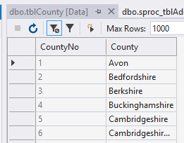

This will select all the data in the table like so…

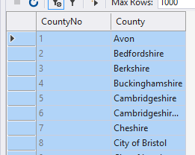

On the keyboard press Ctrl and C to copy the records.

Open a word document and paste the data in as a table. It is probably a good idea to add the table above the data…

